Isolation Gown: sewing directions p.1a
General notes:
These are classified “clean” not “Sterile;” they are reusable but are not intended for surgery or medical grade barrier. They are intended for temporary protection of healthcare workers.
These gowns are put on without any closures or assistance.
Seaming is minimized to reduce any place to trap germs.
This pattern instructions include options for seaming and cuffs depending on your skills
and available materials.

The Patterns:
The scale pattern on graph paper is 1/8th inch scale: each box =2”x2”. There are numbers to clarify how many inches each section of the pattern measures. Draw this out on wrapping or craft paper to make a pattern. OR
The full scale pattern can be printed and the pages taped together to form a full size pattern.

Fabrics:
Tightly woven microfiber, poly, or polycotton sheeting: Microfibers are usually nylon or poly and less absorbent, so better as a barrier for moisture than cotton
Tight weave such as percale is better and less permeable than satin or sateen weaves.
Sheets treated with scotchguard may also help repel moisture.
Fabric Needs to be washable in very hot water and subject to industrial grade detergent and bleach. Some hospitals use UV light and heat to clean as well.

Cutting Layout: NB: this pattern has no seam allowance. Add ½” to neck, armscye, and shoulder seams and 1” to hem and vertical edges.

If fabric is wide enough, as with a queen sheet, cut with center front/center back lines on the lengthwise grain and wide hem of sheet as garment hem. If using yardage, cut on cross grain to allow garment to be cut in one without side seams: hem will follow selvedge edge.

3 ½ yds 45” or one XL twin flat sheet (~60”x100”) If you are purchasing or repurposing sheets, make sure it is at least 72 by 44 to cut the body plus about 24”x24” for each sleeve. You would then use the fitted sheet or pillowcases for the sleeves. See the attached table for standard sheet sizes

If fabric yardage is narrower than 45”, shorten the gown at the hem or use a wide folded strip of fabric to encase and lengthen it: remember that an inch shorter is probably better than more seams. If you need to cut the body in panels, avoid seams on the outside.

If including cuffs, cut two pieces of rib knit, each 6.5” x 6.5” or repurpose knit cuffs from another shirt (or hem of some sweatshirts). You can use a strip of t-shirt knit to finish the neck and armscyes if you do not have bias tape.

Stitching:
Stitching should be secure enough to sustain multiple washings. The garment this was modelled on used a five thread overlock to serge and stitch simultaneously. You may choose to:
- Stitch and zig or overlock seams together
- Flat fell or French seam
- Bind with soft cotton bias or seams great.
You tube has video demos of these processes if you need a refresher.
Isolation Gown: sewing directions p.2a

Sleeves: note that the sleeve seam is on top, from the shoulder, rather than on the inner arm.
- Prepare the cuffs: with elastic casings, knit cuffs, or thumb loop
Option 1: thumb loop: staystitch ¼” from edge , turn twice and restitch to form rolled hem on outer edge and thumbhole.
Option 2: elastic casings: trim away thumb loops as marked: turn hem 1/4” then 3/4” to form elastic casing; inert 6 inches of ¼” elastic and tack at outseam edges
Option 3: trim gown sleeve length as marked. Cut two 6.5” squares of rib knit. fold across rib to make a 3.25” rectangle. Pin cut edges to edge of sleeve, distributing fullness. Stretch ribbed cuff and sew 3 layers together. Serge or zigzag over raw edges ensuring it will still stretch to at least 12”
Option 4: if you are repurposing cuffs from another clean garment, stitch a short section of the sleeve seam together at the cuff edge, and ease fabric to cuff, then serge or zig raw edges together.

- With right sides together, Sew the sleeves to the armscyes as per pattern diagram, matching underarm notch to side notch and sleeve seam to shoulder seam. Serge, zig zag, fell, or bind armseye seam allowances.
- With right sides together, Pin front to back from neckline through shoulder and down arm to sleeve hem. Stitch shoulder and sleeve seams and serge, zig, fell or bind seam allowances.

- Finish necklines (on all sections) and remaining armseye:

Option 1: staystitch ¼” from edge, turn twice and stitch rolled hem
Option 2: bind with bias tape
Option 3: cut a 2” wide strip of cotton knit (tshirt fabric); fold in half and sew raw edges to outside of neckline, serge all raw edges together if possible; turn folded knit away from garment and stitch seam allowance to inside of garment

- Hem side front and side back long edges with ½” rolled hem.
- If lower edge is not already hemmed (for example, if you used a hemmed sheet), turn ¼” then ¾” and stitch to hem.

This garment has no closures.

Isolation Gown: sewing directions p.3a

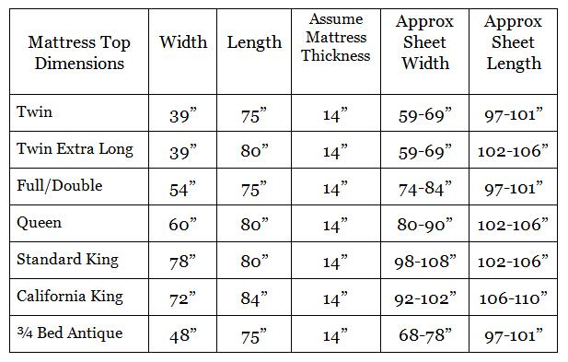
Credit: Skeffling Lavender Farm. On http://www.infobarrel.com/Antique_Bed_Linens_-_Choosing_the_Right_Size_Antique_Linen_Sheets_Coverlets__Bedspreads

This chart may be useful in estimating yardage. A Twin XL will yield one gown, a queen should yield two, etc. The body of the gown is 2 yards (72”) x 45”: you need an additional two 24”x28” pieces for the sleeves.

